BASIC OPERATING INFORMATION
FOR
DRESSMAKER MODEL 1603M SEWING MACHINE
Written by JohnWedding 1/8/2013

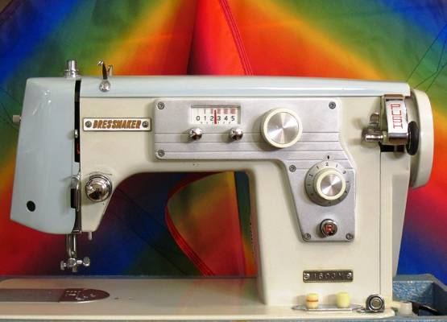

FORWARD

This document was created to serve in the absence of the original operating instruction manual for this sewing machine. I have included all the most important information available that may be specific to this particular machine. I have not included information about basic sewing practices, balancing upper/lower thread tensions, matching needle and thread sizes, etcetera, as this information is commonly found in many other sewing machine manuals and other publications.

INTRODUCTION

This Dressmaker Model 1603M sewing machine was manufactured around 1969 in Japan. It is a “Class-15” machine and uses standard needles and class-15 metal bobbins. It is a well-built machine featuring all metal construction inside and out. This means that with basic care and periodic lubrication, it will likely out sew and easily out last just about any comparable modern domestic machine manufactured today.

It uses only HIGH SHANK presser feet, which is a bit uncommon for a domestic machine in modern times (most are LOW shank), but there are still plenty of feet available from a variety of sources.

Furthermore, this is a LEFT-needle (or LEFT-home) machine, which means that the straight-stitch needle position is the same as the far left zig-zag needle position. When set to do zig-zag stitching, the leftmost needle position is always the same, and the rightmost needle position varies with the zig-zag stitch width setting.

The straight-stitch foot supplied with this machine has the needle opening on the leftmost side to accommodate the LEFT-needle machine design. ALWAYS be certain that the zig-zag stitch width setting is at “0” whenever the straight-stitch presser foot is installed, or the needle will hit the presser foot and damage will occur. NEVER install a straight-stitch foot that is not designed for a LEFT-home needle machine.

Virtually any HIGH SHANK presser foot with a larger opening for zig-zag stitching may be used with this machine. At the time of this writing, a general-purpose zig-zag foot and an open-toe satin-stitch/appliqué foot were also included.
NEEDLE INSTALLATION

- Loosen needle clamp screw
- Orient needle with FLAT side of shank to the RIGHT and insert into needle bar
- Tighten clamp screw

UPPER THREADING

Observe thread path as shown in the following photos:
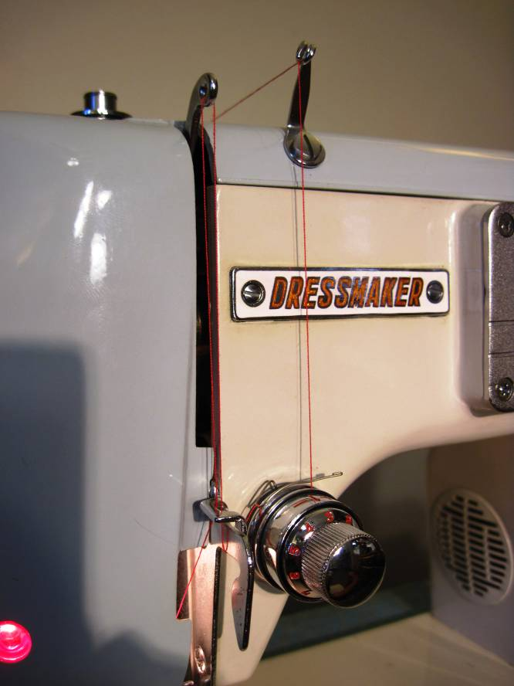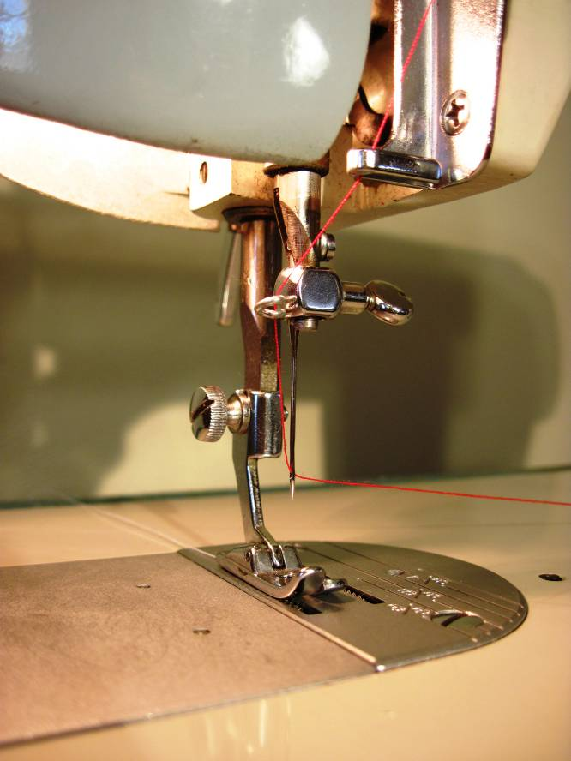

- Place thread spool on spool pin at rear of machine.
- Run thread through both rear and front guides (rear not shown in above photo) on top of machine before continuing down to tension assembly.
- Pass thread between tension disks on RH side of tensioner and wrap thread CW to about the 2-o’clock position. NOTE: ALWAYS fully raise presser foot lever to release pressure on tension assembly before threading.
- Be certain thread is behind take-up spring and pass thread down and under guide at left of tensioner as shown.
- Pass thread up and through slot in guide and continue up to take-up lever above.
- Pass thread from right to left through take-up lever, then back down to guide at left of tensioner.
- Open end cover and pass thread behind lower guide bar, then down through guide at needle clamp. (second photo)
- ALWAYS thread needle from LEFT to RIGHT as shown.
- Close end cover
BOBBIN WINDING

Observe thread path for use when winding bobbin as shown in the following photo:
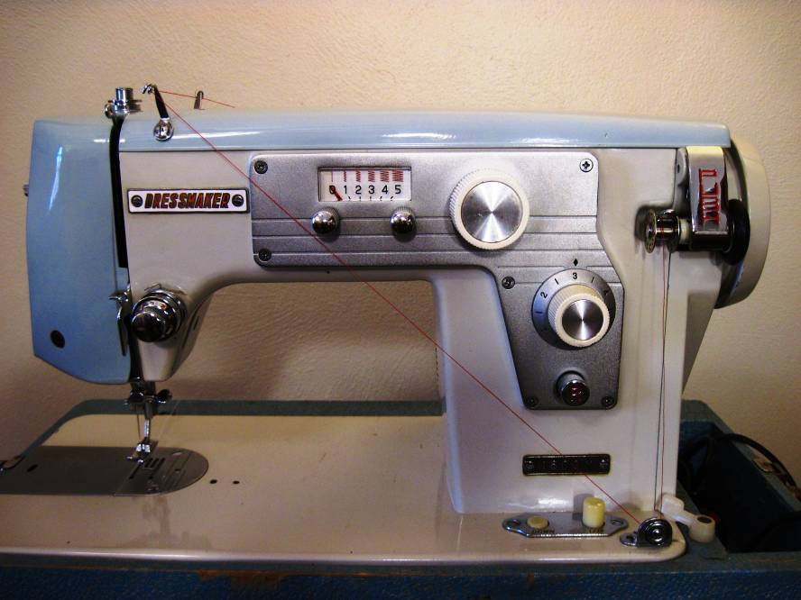

- Loosen stop-motion knob (turn CCW) in center of handwheel to disengage needlebar.
- Place empty bobbin on winder and align notch in bobbin with tab on winder shaft.
- Push-in lever to engage winder.
- Thread machine as shown and pass thread end through a hole in left side of bobbin from the inside out.
- While grasping thread end, run machine motor at moderate speed until a couple of layers of thread have been wound.
- Snip thread end close to bobbin and continue winding bobbin. Winder will automatically disengage when bobbin is fully wound.
- Remove bobbin from winder and tighten (turn CW) stop-motion knob in center of handwheel to reengage needlebar.

INSTALL BOBBIN INTO BOBBIN CASE

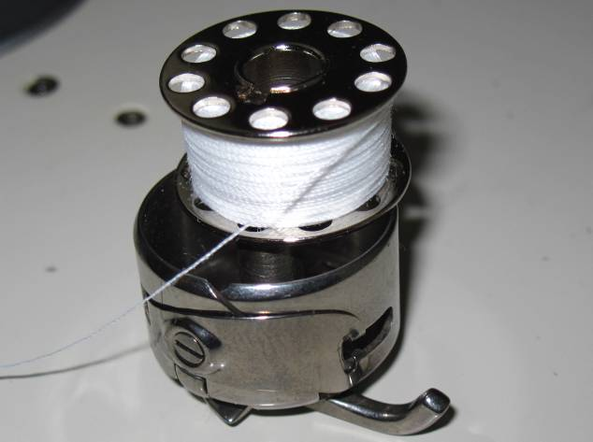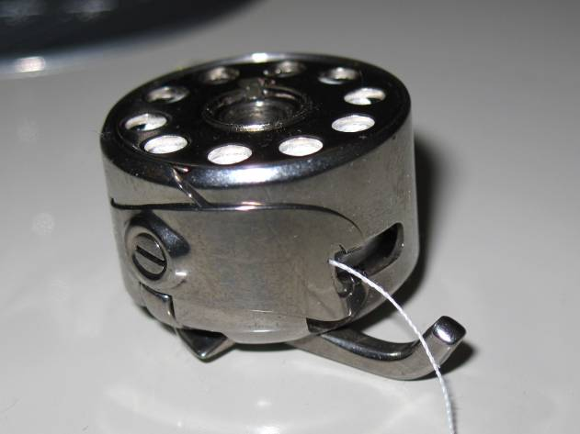

- Orient bobbin to case as shown.
- Insert bobbin into case with thread in slot. Pull thread all the way under flat tension spring as shown.

INSTALL BOBBIN CASE INTO SHUTTLE

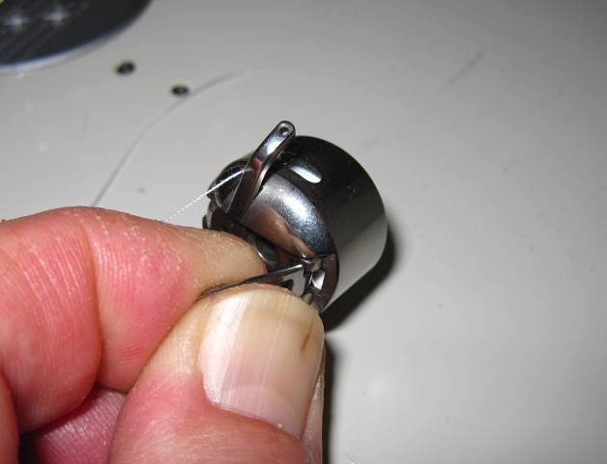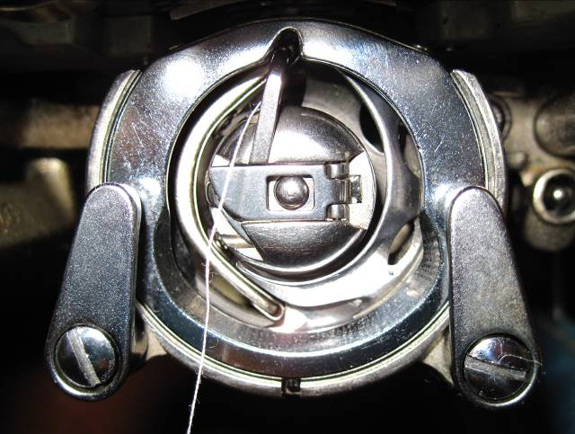

- Rotate handwheel forward until needlebar is at highest position.
- Lift bobbin case latch and hold open as shown. Bobbin will not fall out so long as latch is held open.
- Insert bobbin case into shuttle as shown with “finger” aligned with upper notch in shuttle race cover. Be certain to push it all the way in. Also note that bobbin thread should be on the left side of bobbin case finger.
- Release bobbin case latch.
- Gently pull on bobbin thread. Bobbin case should not fall out and bobbin should rotate freely.

Removing Bobbin Case from Shuttle

- Rotate handwheel forward until needlebar is at highest position.
- Lift bobbin case latch and grasp firmly between thumb and index finger.
- Pull outward to remove bobbin case with bobbin. Bobbin will not fall out so long as latch is held open.
DRAW BOBBIN THREAD UP THROUGH NEEDLE PLATE

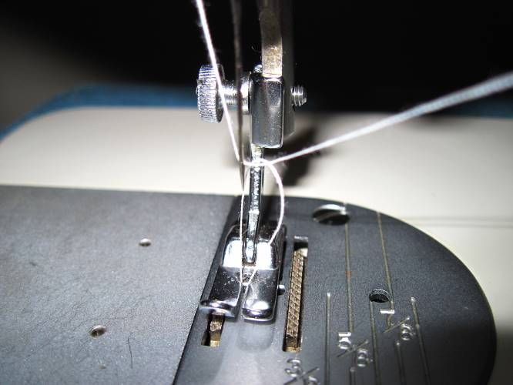

- Raise presser foot lever to highest position to release needle thread tension.
- Gently pull about 5 inches of thread from needle.
- Lower feed dogs. (See pg. 6)
- Lower presser foot lever.
- Rotate handwheel forward one revolution or until take-up lever is at highest position.
- Carefully pull end of needle thread upwards.
- Loop of bobbin thread should become visible above opening in needle plate.
- Pull bobbin thread through needle plate until end of thread is clear of plate. Leave about 5 inches of thread.
- Raise presser foot lever.
- Raise feed dogs. (See pg. 6)
- Pull threads under presser foot and towards the rear.

STITCH LENGTH and REVERSE

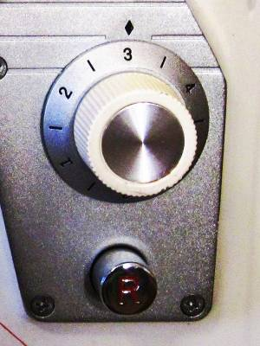
Stitch Length Dial
Reverse Button

Turn Stitch Length Dial to desired position to set length of stitch:

“0” = No feed (feed dogs move up/down but not fwd/rev)
“0 to 1” = Shortest Stitch Length (range for satin-stitching using zig-zag)
“5” = Longest Stitch Length

Press Reverse Button “R” at beginning and end of stitch line to prevent seam from separating at ends. Two or three reverse stitches are typically sufficient.
ZIG-ZAG STITCHING

Setting zig-zag stitch width is done through the use of the stitch width control knob and the locking knobs.

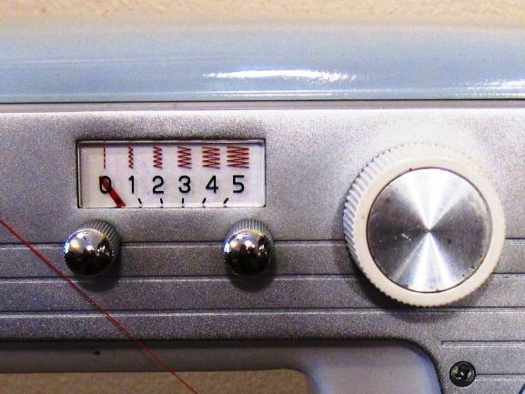
ZIG-ZAG
STITCH WIDTH LOCKING KNOBS
ZIG-ZAG STITCH WIDTH CONTROL KNOB
STITCH WIDTH INDICATOR

- Rotate handwheel forward until needlebar is at highest position.
- Install general-purpose zig-zag foot or other suitable zig-zag-capable foot.
- Loosen both stitch width locking knobs (turn CCW).
- Turn stitch width control knob CW to desired setting and hold in position. (Note-control knob will return to zero if released.) Red pointer indicates stitch width setting.
- Tighten stitch width locking knobs while holding stitch width control in position.
- Stitch width control will now remain at set position.

NOTES:
- NEVER change stitch width setting while needle is down in fabric.
- ALWAYS return stitch width control to “0” whenever straight stitch foot is installed.

FEED DOG HEIGHT

Observe the feed dog button controls in the photos below:

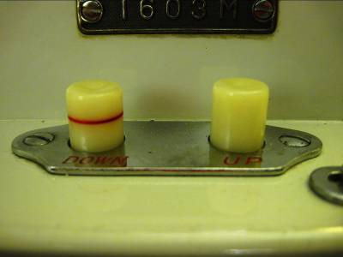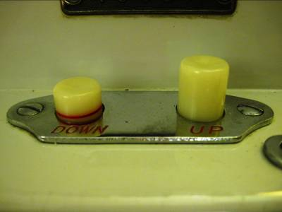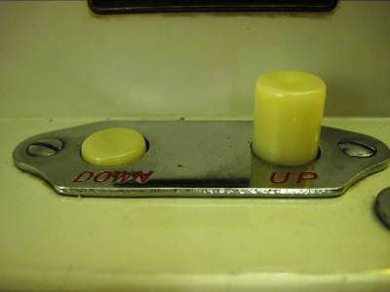

This machine incorporates a pushbutton mechanism to control feed dog height. There are (3) three feed dog positions:

- UP – used for most normal sewing and fabrics
- LOW – sometimes used for delicate fabrics
- DOWN – Useful for doing free-motion work (when used with darning/embroidery presser foot)
PRESSER FOOT PRESSURE

Lightest Setting
Pressure Setting Button-
Press to increase foot pressure
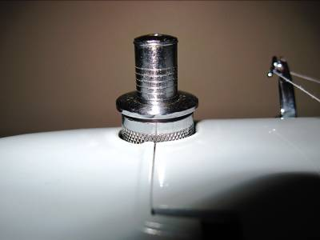
Locking Collar-
Press to release button and decrease pressure

Normal Setting
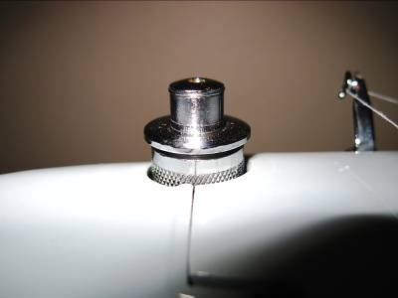

Heaviest Setting
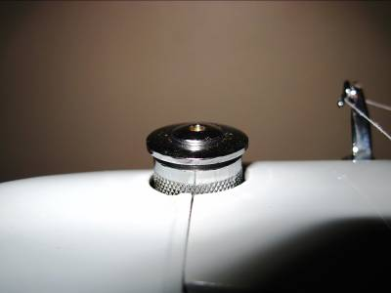

Light pressure settings may be required for delicate fabrics.

Heavier pressure settings may be required to properly feed heavier materials such as upholstery cloth or heavyweight denims.

Pressure should be set just heavy enough to consistently feed material being sewn.

REMOVE SHUTTLE FOR CLEANING

Fabrics and thread have a tendency to shed material, and a lot of that material can collect in the shuttle area below the needle plate.

It is important to keep the shuttle area and feed dogs free of lint and debris. Use of a suitable brush (small pastry brush or similar), or even a small vacuum brush/nozzle are the best tools for cleaning.

Avoid blowing or using compressed air as this can cause debris to become lodged in hard-to-reach places.

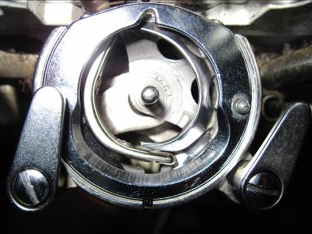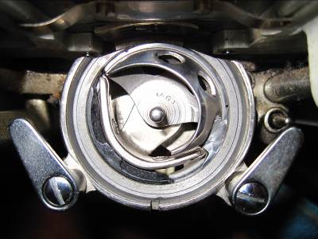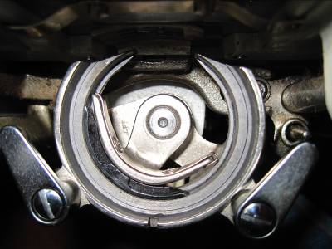

Shuttle Race Cover Retainers
Shuttle Race Cover
Shuttle
Shuttle Driver

Shuttle Race
- Rotate handwheel until needlebar is at highest position.
- Open shuttle race cover retainers.
- Remove shuttle race cover.
- Remove shuttle.
- Clean shuttle area with vacuum and/or small brush. Rotate handwheel to move shuttle driver to allow access to entire shuttle race.
- Wipe entire shuttle race with Q-tip.
- Thoroughly clean shuttle and shuttle race cover.
- Rotate handwheel until needlebar is at highest position.
- Replace shuttle.
- Replace shuttle race cover.
- Close shuttle race cover retainers.
- Rotate handwheel forward one revolution to ensure shuttle is properly seated and no binding occurs.

MAINTENANCE & LUBRICATION

This sewing machine is capable of performing flawlessly for years and years to come, provided it is not abused, and is kept clean and properly lubricated.

If you’ve had experience with owning and maintaining a sewing machine or two in the past, then you’re probably already comfortable with removing the top cover and lubricating all moving parts there, as well as underneath the bed of the machine.

If you are not comfortable with servicing the machine yourself, there are a few options. One option is to learn by researching the many resources online. There is a wealth of general information available on the subject, and it is not particularly difficult to learn to do for most people.

Another option is to regularly have the machine serviced at a reputable shop in your local area. Having the machine maintained and lubricated by a professional is far less costly than waiting until problems arise and repairs are needed.

If you choose to lubricate the machine yourself, then the following should be carefully observed:

- Unplug the machine from electrical power source.
- NEVER use anything but a quality SEWING MACHINE OIL to lubricate the machine. DO NOT USE motor oil, 3-in-1, WD-40, etc. as these can cause more harm than good.
- DO NOT OIL the MOTOR. This is best left to the professional shop unless you really do know what you are doing. Excess oil in the motor is a very bad thing.
- Unthread the machine, and remove the bobbin case/bobbin. Also, remove the needle and presser foot.
- Remove the two screws and the top arm cover to gain access to the lubrication points in the upper arm area.
- Set the stitch width to widest setting.
- Rotate the handwheel by hand while observing which parts move. It’s usually easy enough to identify all points of moving metal-to-metal contact. In many instances, there will be a visible oil hole at pivot points, so look carefully to find them.
- Place a single drop of oil on each of these moving points. A little bit of oil goes a long way-avoid over-oiling. Using a syringe oiler or fine-tip applicator is highly recommended.
- Make certain to lubricate all pivot points, as well as any point where a shaft rotates or moves in and out of a bushing or bearing. The main horizontal shaft has oiling holes on the top of the bushing locations.
- Swing open the end cover to gain access to the needlebar area.
- Again, rotate the handwheel and observe all points of movement. Look for oil holes, and apply a drop of oil to each point of movement.
- There are also moving points that are not driven by the motor, such as the presser foot bar and lifting lever mechanism. These don’t need lubricated as often, but should not be overlooked. Also, place a single drop of oil into the hole on top of the presser foot pressure button on top of the machine.
- Wipe away any excess oil or drips as they occur.
- Carefully tip the machine back on its hinges to gain access to the underside of the bed. Support the back of the machine with something suitable to avoid bending the spool pins and bracket.
- Again, rotate the handwheel and observe all points of movement. Look for oil holes, and apply a drop of oil to each point of movement.
- Return machine to upright position.
- Reconnect machine to power source and run at low to moderate speed for a short time to distribute oil.
- Wipe away any excess oil that may have been thrown-off as needed.
- Replace arm top cover and screws.

